**Investigating 1st Class Levers**

**Aim:** To examine the relationship between forces and distances in first-class levers.

**Equipment:** 30 cm wooden ruler

Wooden rod

4 x 50g masses

Spring balances

**Part 1: Changing the distance between load and fulcrum**

**Method:**

1. Lay the ruler across the wooden rod so that it balances in the middle (15 cm). This is the fulcrum.
2. Place four masses 12cm from the fulcrum (on the 3cm mark). This is a load of approximately 2N. Look at the picture below if you are not sure.
3. Using the push end of the blue spring balance, apply an effort to the other end of the ruler on the 27cm mark until the ruler is horizontal.
4. Record the effort in the table and repeat twice more to find an average.
5. Move the **load** 3cm closer to the fulcrum and repeat steps 3 to 5 until the load is 3cm away from the fulcrum.

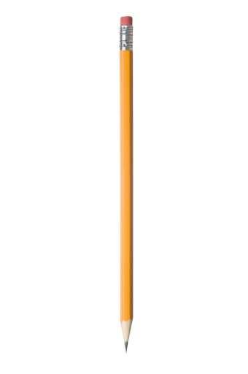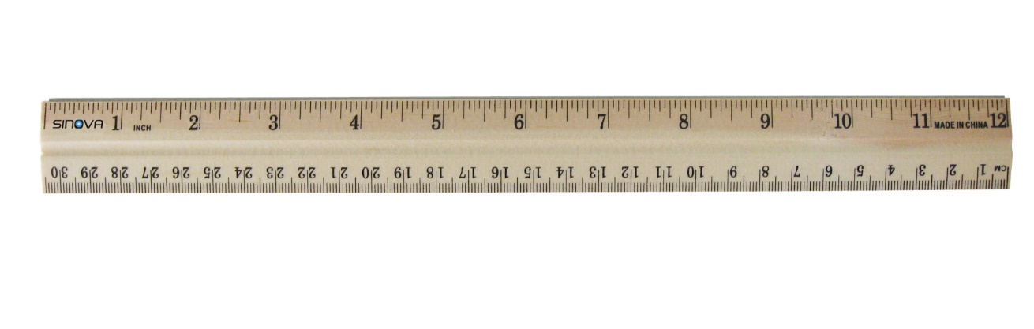

Fulcrum

Load (12 cm from fulcrum)

Effort

**Results:**

|  |  |  |  |  |  |  |
| --- | --- | --- | --- | --- | --- | --- |
| Load (N) | Load Distance from Fulcrum (cm) | Effort 1 (N) | Effort 2 (N) | Effort 3 (N) | Average Effort (N) | Mechanical Advantage |
| 2 | 12 |  |  |  |  |  |
| 2 | 9 |  |  |  |  |  |
| 2 | 6 |  |  |  |  |  |
| 2 | 3 |  |  |  |  |  |

**Questions:**

1. Calculate the mechanical advantage of each lever using the formula below and record it in the table.
2. Describe any pattern you can see in the data you have collected.
3. From the results of your experiment, is it better to have the **load** close to or far from the fulcrum? Explain your choice.

**Part 2: Changing the distance between effort and fulcrum**

**Method:**

1. Lay the ruler across the wooden rod so that it balances in the middle (15 cm). This is the fulcrum.
2. Place four masses 12cm from the fulcrum (on the 3cm mark). This is a load of approximately 2N. Look at the picture below if you are not sure.
3. Using the push end of the blue spring balance, apply an effort to the other end of the ruler on the 27cm mark until the ruler is horizontal.
4. Record the effort in the table and repeat twice more to find an average.
5. Move the **effort** 3cm closer to the fulcrum and repeat steps 3 to 5 until the load is 3cm away from the fulcrum.

**Results:**

|  |  |  |  |  |  |  |
| --- | --- | --- | --- | --- | --- | --- |
| Load (N) | Effort Distance from Fulcrum (cm) | Effort 1 (N) | Effort 2 (N) | Effort 3 (N) | Average Effort (N) | Mechanical Advantage |
| 2 | 12 |  |  |  |  |  |
| 2 | 9 |  |  |  |  |  |
| 2 | 6 |  |  |  |  |  |
| 2 | 3 |  |  |  |  |  |

**Questions:**

1. Calculate the mechanical advantage of each lever using the formula below and record it in the table.
2. Describe any pattern you can see in the data you have collected.
3. From the results of your experiment, is it better to have the **effort** close to or far from the fulcrum? Explain your choice.